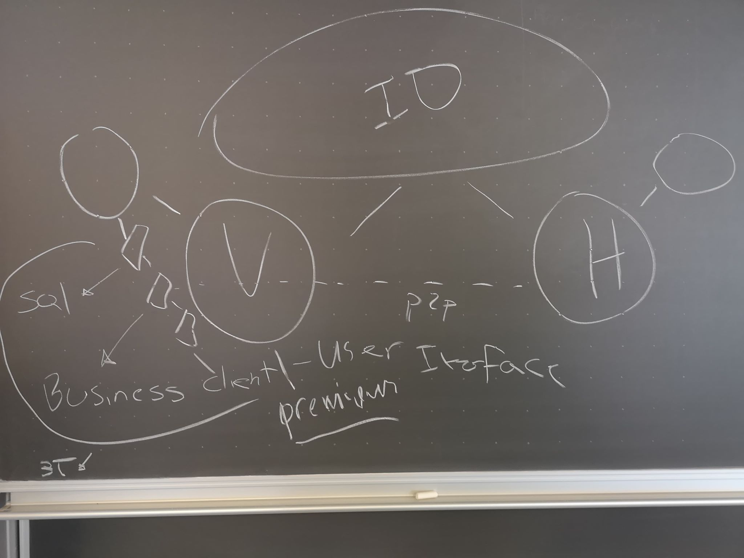

* Two centers one in Viborg and one in Horsens
* Regular member only can access user interface to see events for that center only
* Premium member can access user interface for both centers
* Both centers has a three-tier-architecture consisting of
* Tier-1 = the SQL part connecting to the database. Also a server for tier-2.
* Tier-2 = the business, this is where the distributed part kicks in, this is also a server.
* Tier-3 = the client. Also where the user interface is code for the centers.
* There is a p2p connection between the two centers(distributed system).
* Each center has a database. Now the two databases need to connect, this is done by having a different id for each center.
* In order to make the systems heterogenous the one of tier could be coded in another language fx. The client.